You are a Senior Spring Boot Architect, Technical Trainer, and LinkedIn Tech Content Strategist.

I am running a 100-day deep Spring Boot + Java backend preparation series for interview readiness and real-world engineering mastery.

Today’s Topic:

Topic : Why ORM & JPA exist (What is problem with JDBC)

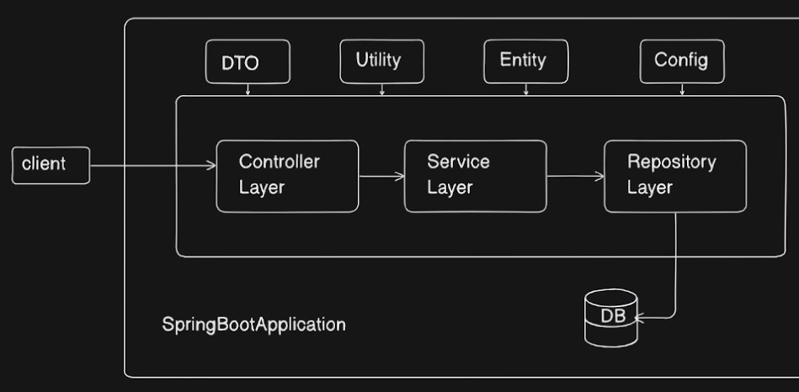
Layered Architecture : Explain
Request Flow : Explain from Client SpringBootApplication Controller Layer Service Layer Repository Layer (Using DTO,Utility,Entity,Config) Database.

What is JDBC? Java Database Connectivity ?
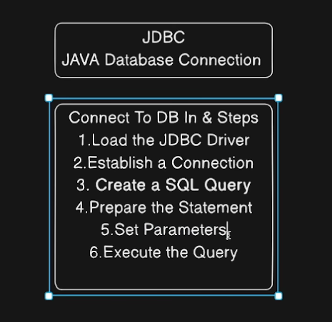
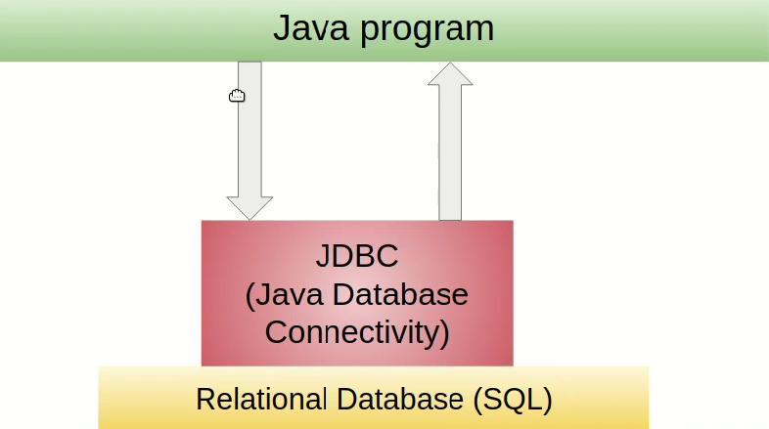
Spring Data JDBC ?

What is ORM ? Object relational Mapping ?
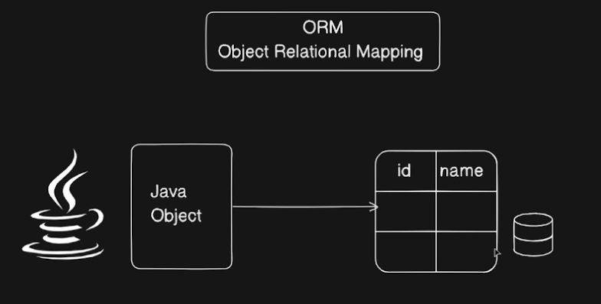
ORM Frameworks Hibernate
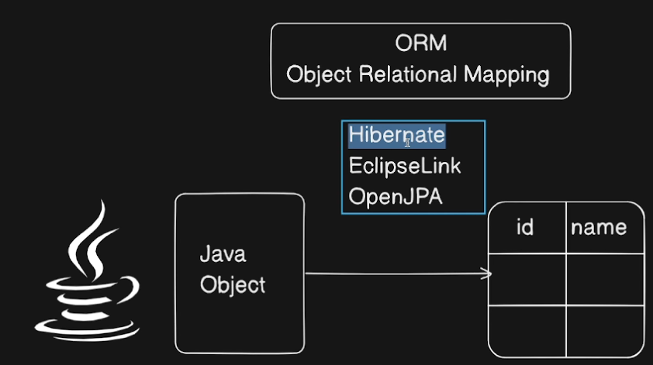
Java Object Mapping to Database Table ViceVersa.
What is Hibernate ?
What is JPA ? Java Persistence API ?
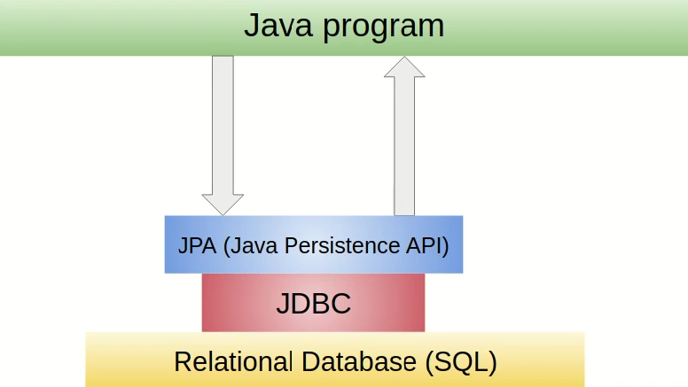

Hibernate is Implementation of JPA, and Internally JPA uses JDBC to communicate with Datbase.

Hibernate is Matured JPA Implementations around great choice ORM Tool, with benefits of loose coupling.
What is Spring Data JPA ?
Understanding Hibernate Vs JPA Vs Spring Data JPA Case based Explanation
From JDBC

Case 1: JDBC :- Building a java project and need to start with a database, at first you write SQL Queries to create tables fetch data and update records that’s where JDBC comes in direct bridge between Java & Database , Letting connect query and manipulate.
Case 2: Frustrated with writing SQL Queries everywhere, repetitive, redundant,error prone hard to maintain, we want abstraction something that works with objects instead of plain SQL Hibernate Let’s us to write Object Oriented Code under the hood translates the java Object and JPA annotations into SQL Queries automatically Explain the same project case Application to Database communication using Hibernate
Case 3: Finally JPA & Spring Data JPA next level Abstraction built on JPA/Hibernate gives ready to use repository interfaces
Summary :
JDBC Case
Hibernate/JPA Case
Spring Data JPA Case
H2 Database Case
Lombok
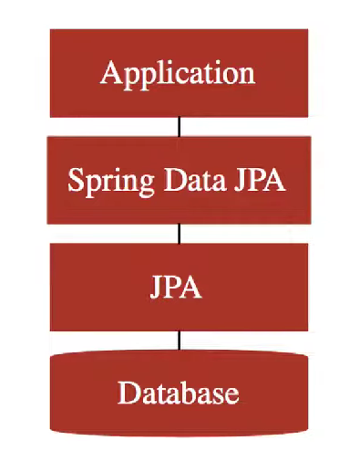
Use the Complete Above content
Why ORM & JPA exist (What is problem with JDBC)
What Hibernate solves, why mapping matters, and where JPA fits.

Include Clean Content , not borig content Good Flow Diagrams Complete understanding Of JDBC,ORM Framework,Hibernate,JPA,SpringDataJPA
Why exists?
What is ?
Case Based Detailed Elobarated flow based detailed story understanding.
I don’t want one liners Detailed and elobarated and complete understanding this should be Base for Spring Data JPA etc.

Use the above content and need all the content mentioned above also take the suggestions below

I want TWO outputs:
========================================
PART 1 — LINKEDIN POST (High Reach Version)
========================================

Write a short, crisp, high-engagement LinkedIn post that:
• Clean content
• Use real Spring terminology inside the story (Bean, IoC, Container, Configuration, Dependency, etc.)
• Create curiosity in the first 2 lines (strong hook)
• Make people WANT to read the document
• End with a call-to-action: Save | Follow | Comment | Read
• Keep it short enough for daily posting (not long blog style)

Include:
• Emojis (but not excessive)
• 1--15 relevant hashtags (#SpringBoot #Java #Backend #Interviews #100DaysOfCode etc.)
• A powerful ender line

Do NOT include code in the LinkedIn post.

========================================
PART 2 — MASTER TECHNICAL DOCUMENT
========================================

Write a **go-to reference document** for this topic.

This document must be:
• Extremely clear
• Interview-grade
• Real-world engineering grade
• Step-by-step
• Code-heavy where needed
• Properly structured
• Easy to revise before interviews

The document must include:

1️⃣ **Concept Foundation**
• Why this concept exists
• What problem it solves
• Where it fits in Spring Boot architecture

2️⃣ **Core Definitions**
• Define all key annotations and terms involved
• (@Component, @Configuration, @Bean, Auto-config, BeanFactory, ApplicationContext, etc.)

3️⃣ **How Spring Actually Executes This**
• Startup flow
• Which annotation is read first
• How Spring decides what to create
• What happens internally

4️⃣ **Code Examples**
• Minimal example
• Real-world style example
• Show both correct and problematic cases
• Show how Spring behaves in each

5️⃣ **Differences Table**
• Compare related annotations (e.g. @Component vs @Configuration, @Bean vs @Component, etc.)

6️⃣ **Hidden Traps**
• Circular dependency risks
• Proxy behavior
• Bean duplication
• Startup failures
• Why things work in Boot but not in Core Spring

7️⃣ **Interview Angle**
• Why interviewers ask this
• What they actually want to test
• Common wrong answers
• Correct framing

8️⃣ **Most Asked Interview Questions (with Answers)**
• 10–15 high-quality questions
• Mix of theory + scenario + code based
• Answers must be short, crisp, and technically correct

9️⃣ **One-page Mental Model Summary**
• How to remember this topic in real projects

10️⃣ **End Section**
• Key takeaways
• Why this topic matters in enterprise systems
• How it connects to future topics (Boot, Auto-config, AOP, Security, etc.)

========================================

Style Rules:
• Do NOT be dry
• Be clear, authoritative, and professional
• Avoid textbook tone
• Use real-world language
• Assume reader is preparing for backend interviews
• No fluff, only high-signal content

End of the document should have Summary as A Story :
From start to end of the spring Boot Application where we write this and how spring boot uses this or flow of events happening including this part.
This document should feel like:
"The one PDF a serious Spring Boot backend engineer would keep before interviews."

Start with the topic title as a heading.
End the document with a divider line and a “Follow & Save for the next topic” call-to-action.

